10B EMS Overview Activity
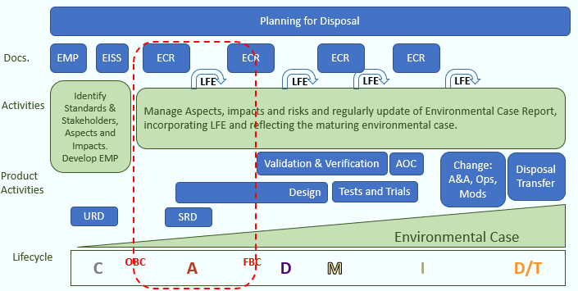
Choose a process that is available to you?
  - Risk / Impact Identification
  - Legislation Management
  - Requirements Management
  - Sustainable Procurement
Consider:
Who provides these processes?
How would you use these processes?

